 | CÔNG TY CP BẢO TRÌ KỸ THUẬT CÔNG NGHIỆP  Trụ sở: Lầu 1, số 788/51C Nguyễn Kiệm, P.3, Q.Gò Vấp, TP.HCM  Tel: 08.66749689, 0913771002, Fax: 08.62835279, MST: 0305901954, .  Web site : http://www.vanduongong.com, Emai:baotri.kythuat@gmail.com

BẢNG THÔNG TIN QUẠT INNO TECH NĂM 2015
Sản Phẩm |  |  | Thông số kỹ thuật
Model | Hình ảnh |  |  | Power  (pha/V/Hz) | P  (W) | Q  (m3/h) | Áp lực  (mmAq) | T. độ  (Rpm) | T. ồn  (dB) | m  (Kg)
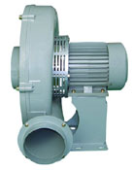
Quạt thổi khí áp suất cao đa cấp (Hight-pressure multilevel blowers)
 |  |  |  | 1/220/50 | 1,100 | 1,380 | 226 | 2,900
ITB-S411T |  |  |  | 3/220-380/60 | 1,750 | 1,620 | 300 | 3,370 | 80 | 24
ITB-S411T |  |  |  | 3/220-380/50 | 1,100 | 1,380 | 226 | 2,900 | 80 | 24
ITB-411S | 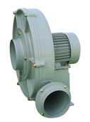 |  |  | 1/220/60 | 1,750 | 1,620 | 300 | 3,400 | 80 | 23
ITB-411S |  |  |  | 1/220/50 | 1,100 | 1,380 | 226 | 2,900 | 80 | 23
ITB-411T |  |  |  | 3/220-380/60 | 1,750 | 1,620 | 300 | 3,370 | 80 | 23
ITB-411T |  |  |  | 3/220-380/50 | 1,100 | 1,380 | 226 | 2,900 | 80 | 23
ITB-412T | 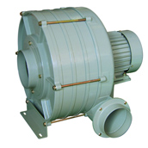 |  |  | 3/220-380/60 | 2,050 | 1,200 | 555 | 3,400 | 82 | 32
ITB-412T |  |  |  | 3/220-380/50 | 1,330 | 1,020 | 405 | 2,900 | 82 | 32
ITB-413T |  |  |  | 3/220-380/60 | 2,650 | 1,200 | 725 | 3,459 | 85 | 38
ITB-413T |  |  |  | 3/220-380/50 | 1,780 | 1,020 | 510 | 2,940 | 85 | 38
ITB-414T |  |  |  | 3/220-380/60 | 3,300 | 1,200 | 1,100 | 3,485 | 86 | 42
ITB-414T |  |  |  | 3/220-380/50 | 2,200 | 1,020 | 775 | 2,920 | 86 | 42
ITB-S412T | 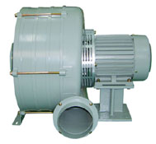 |  |  | 3/220-380/60 | 2,050 | 1,200 | 555 | 3,400 | 82 | 33
ITB-S412T |  |  |  | 3/220-380/50 | 1,330 | 1,020 | 405 | 2,900 | 82 | 33
ITB-S413T |  |  |  | 3/220-380/60 | 2,650 | 1,200 | 725 | 3,459 | 85 | 39
ITB-S413T |  |  |  | 3/220-380/50 | 1,780 | 1,020 | 510 | 2,094 | 85 | 39
ITB-S414T |  |  |  | 3/220-380/60 | 3,300 | 1,200 | 1,100 | 3,485 | 86 | 43
ITB-S414T |  |  |  | 3/220-380/50 | 2,200 | 1,020 | 775 | 2,920 | 86 | 43
ITB-401S | 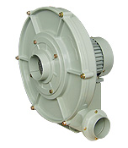  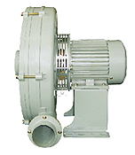 |  |  | 1/220/60 | 1,080 | 600 | 352 | 3,435 | 83 | 20.5
ITB-401S |  |  |  | 1/220/50 | 725 | 510 | 260 | 2,925 | 83 | 20.5
ITB-401T |  |  |  | 3/220-380/60 | 1,180 | 600 | 352 | 3,390 | 83 | 20.5
ITB-401T |  |  |  | 3/220-380/50 | 735 | 510 | 260 | 2,920 | 83 | 20.5
ITB-402S |  |  |  | 1/220/60 | 1,525 | 630 | 635 | 3,480 | 83 | 25.5
ITB-402S |  |  |  | 1/220/50 | 1,330 | 540 | 465 | 2,938 | 83 | 25.5
ITB-402T |  |  |  | 3/220-380/60 | 1,610 | 630 | 635 | 3,450 | 83 | 25.5
ITB-402T |  |  |  | 3/220-380/50 | 900 | 540 | 465 | 2,942 | 83 | 25.5
ITB-S401S |  |  |  | 1/220/60 | 1,080 | 600 | 352 | 3,435 | 83 | 21.5
ITB-S401S |  |  |  | 1/220/50 | 725 | 510 | 260 | 2,925 | 83 | 21.5
ITB-S401T |  |  |  | 3/220-380/60 | 1,180 | 600 | 352 | 3,390 | 83 | 21.5
ITB-S401T |  |  |  | 3/220-380/50 | 735 | 510 | 260 | 2,920 | 83 | 21.5
ITB-S402S |  |  |  | 1/220/60 | 1,525 | 630 | 635 | 3,480 | 83 | 26.5
ITB-S402S |  |  |  | 1/220/50 | 1,330 | 540 | 465 | 2,938 | 83 | 26.5
ITB-S402T |  |  |  | 3/220-380/60 | 1,610 | 630 | 635 | 3,450 | 83 | 26.5
ITB-S402T |  |  |  | 3/220-380/50 | 900 | 540 | 465 | 2,942 | 83 | 26.5
Sò cao áp (Turbo blowers)
TBS-3235S | 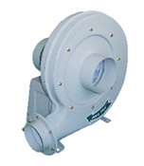 |  |  | 1/220/60 | 1,300 | 1,560 | 265 | 3,410 | 83 | 35
TBS-3235S |  |  |  | 1/220/50 | 900 | 1,365 | 196 | 2,850 | 83 | 35
TBS-3235T |  |  |  | 3/220-380/60 | 1,300 | 1,560 | 265 | 3,410 | 83 | 35
TBS-3235T |  |  |  | 3/220-380/50 | 856 | 1,365 | 196 | 2,850 | 83 | 35
TBS-S3235S | 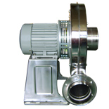 |  |  | 1/220/60 | 1,300 | 1,560 | 265 | 3,410 | 83 | 35.5
TBS-S3235S |  |  |  | 1/220/50 | 900 | 1,365 | 196 | 2,850 | 83 | 35.5
TBS-S3235T |  |  |  | 3/220-380/60 | 1,300 | 1,560 | 265 | 3,410 | 83 | 35.5
TBS-S3235T |  |  |  | 3/220-380/50 | 856 | 1,365 | 196 | 2,850 | 83 | 35.5
TBS-3245S |  |  |  | 1/220/60 | 1,800 | 2,400 | 285 | 3,460 | 87 | 40
TBS-3245S |  |  |  | 1/220/50 | 1,540 | 2,100 | 210 | 2,920 | 87 | 40
TBS-3245T |  |  |  | 3/220-380/60 | 1,800 | 2,400 | 285 | 3,460 | 87 | 40
TBS-3245T |  |  |  | 3/220-380/50 | 1,540 | 2,100 | 210 | 2,920 | 87 | 40
TBS-S3245S |  |  |  | 1/220/60 | 1,800 | 2,400 | 285 | 3,460 | 87 | 40
TBS-S3245S |  |  |  | 1/220/50 | 1,540 | 2,100 | 210 | 2,920 | 87 | 40
TBS-S3245S |  |  |  | 3/220-380/60 | 1,800 | 2,400 | 285 | 3,460 | 87 | 40
TBS-S3245S |  |  |  | 3/220-380/50 | 1,540 | 2,100 | 210 | 2,920 | 87 | 40
TBS-3735S  (3HP) |  |  |  | 1/220/60 | 2,800 | 3,120 | 320 | 3,450 | 90 | 45
TBS-3735S  (3HP) |  |  |  | 1/220/50 | 2,300 | 2,730 | 237 | 2,915 | 90 | 45
TBS-3735T  (3HP) |  |  |  | 3/220-380/60 | 2,800 | 3,120 | 320 | 3,450 | 90 | 45
TBS-3735T  (3HP) |  |  |  | 3/220-380/50 | 2,300 | 2,730 | 237 | 2,915 | 90 | 45
TBS-3765T  (5HP) |  |  |  | 3/220-380/60 | 4,200 | 4,020 | 380 | 3,460 | 92 | 50
TBS-3765T  (5HP) |  |  |  | 3/220-380/50 | 3,400 | 3,510 | 280 | 2,980 | 92 | 50
TBS-S3735S  (3HP) |  |  |  | 1/220/60 | 2,800 | 3,120 | 320 | 3,450 | 90 | 46
TBS-S3735S  (3HP) |  |  |  | 1/220/50 | 2,300 | 2,730 | 237 | 2,915 | 90 | 46
TBS-S3735T  (3HP) |  |  |  | 3/220-380/60 | 2,800 | 3,120 | 320 | 3,450 | 90 | 46
 |  |  |  | 3/220-380/50 | 2,300 | 2,730 | 237 | 2,915 | 90 | 46
TBS-S3765T  (5HP) |  |  |  | 3/220-380/60 | 4,200 | 4,020 | 380 | 3,460 | 92 | 51
TBS-S3765T  (5HP) |  |  |  | 3/220-380/50 | 3,400 | 3,510 | 280 | 2,980 | 92 | 51
Cabinet fans-Double inlet & blower for dust collectors
ITC-230GS | 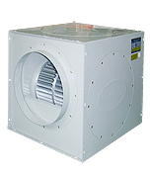 |  |  | 1/220/60 | 320 | 1,800 | 24 | 1,160 | 61 | 26
ITC-230GS |  |  |  | 1/220/50 | 190 | 1,440 | 16 | 960 | 61 | 26
ITC-230GT |  |  |  | 3/220-380/60 | 240 | 1,800 | 24 | 1,150 | 61 | 26
ITC-230GT |  |  |  | 3/220-380/50 | 170 | 1,440 | 16 | 950 | 61 | 26
ITC-250GS |  |  |  | 1/220/60 | 570 | 2,900 | 35 | 1,100 | 63 | 33
ITC-250GS |  |  |  | 1/220/50 | 340 | 2,320 | 24 | 940 | 63 | 33
ITC-250GT |  |  |  | 3/220-380/60 | 560 | 2,900 | 35 | 1,120 | 63 | 33
ITC-250GT |  |  |  | 3/220-380/50 | 390 | 2,320 | 24 | 945 | 63 | 33
ITC-300GS | 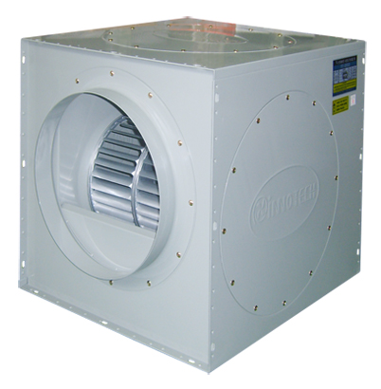 |  |  | 1/220/60 | 1,190 | 4,500 | 50 | 1,120 | 68 | 51
ITC-300GS |  |  |  | 1/220/50 | 710 | 3,800 | 37 | 960 | 68 | 51
ITC-300GT |  |  |  | 3/220-380/60 | 1,140 | 4,500 | 50 | 1,145 | 68 | 51
ITC-300GT |  |  |  | 3/220-380/50 | 680 | 3,800 | 37 | 970 | 68 | 51
ITC-380HS |  |  |  | 1/220/60 | 1,500 | 8,500 | 54 | 810 | 70 | 66
ITC-380HS |  |  |  | 1/220/50 | 910 | 7,100 | 46 | 710 | 70 | 66
ITC-380HT |  |  |  | 3/220-380/60 | 1,450 | 8,500 | 54 | 815 | 70 | 66
ITC-380HT |  |  |  | 3/220-380/50 | 870 | 7,100 | 46 | 720 | 70 | 66
ITC-400GT |  |  |  | 3/220-380/60 | 3,500 | 12,000 | 88 | 1,100 | 75 | 66
ITC-400GT |  |  |  | 3/220-380/50 | 2,100 | 10,200 | 73 | 950 | 75 | 66
Sò nhỏ (Small sirocco blowers)
TIS-140FS | 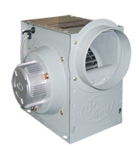 |  |  | 1/220/60 | 60 | 510 | 12 | 1,365 | 42 | 4.5
TIS-140FS |  |  |  | 1/220/50 | 48 | 443 | 9 | 1,335 | 42 | 4.5
TIS-160FS |  |  |  | 1/220/60 | 131 | 900 | 20 | 1,350 | 53 | 7
TIS-160FS |  |  |  | 1/220/50 | 105 | 783 | 16 | 1,335 | 53 | 7
TIS-190FS | 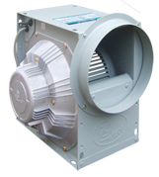 |  |  | 1/220/60 | 360 | 1,260 | 31 | 1,530 | 56 | 10.5
TIS-190FS |  |  |  | 1/220/50 | 288 | 1,090 | 24 | 1,410 | 56 | 10.5
TIS-190FT |  |  |  | 3/220-380/60 | 360 | 1,260 | 31 | 1,510 | 56 | 10.5
TIS-190FT |  |  |  | 3/220-380/50 | 278 | 1,090 | 24 | 1,395 | 56 | 10.5
TIS-250GS  (Ø250 x 130) | 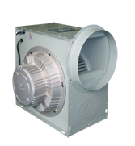 |  |  | 1/220/60 | 428 | 2,520 | 25 | 1,130 | 60 | 20.3
TIS-250GS  (Ø250 x 130) |  |  |  | 1/220/50 | 342 | 2,190 | 19 | 985 | 60 | 20.3
TIS-250GT  (Ø250 x 130) |  |  |  | 3/220-380/60 | 428 | 2,520 | 25 | 1,150 | 60 | 20.3
TIS-250GT  (Ø250 x 130) |  |  |  | 3/220-380/50 | 328 | 2,190 | 19 | 990 | 60 | 20.3
TIS-280FS  (Ø250 x 130) |  |  |  | 1/220/60 | 1,280 | 3,600 | 45 | 1,725 | 64 | 22.3
TIS-280FS  (Ø250 x 130) |  |  |  | 1/220/50 | 935 | 3,060 | 35 | 1,460 | 64 | 22.3
TIS-280FT  (Ø250 x 130) |  |  |  | 3/220-380/60 | 1,280 | 3,600 | 45 | 1,710 | 64 | 22.3
TIS-280FT  (Ø250 x 130) |  |  |  | 3/220-380/50 | 890 | 3,060 | 35 | 1,455 | 64 | 22.3
TIS-280GS  (Ø250 x 150) |  |  |  | 1/220/60 | 514 | 3,240 | 27 | 1,125 | 62 | 22.3
TIS-280GS  (Ø250 x 150) |  |  |  | 1/220/50 | 412 | 2,820 | 21 | 980 | 62 | 22.3
TIS-280GT  (Ø250 x 150) |  |  |  | 3/220-380/60 | 514 | 3,240 | 27 | 1,150 | 62 | 22.3
TIS-280GT  (Ø250 x 150) |  |  |  | 3/220-380/50 | 398 | 2,820 | 21 | 985 | 62 | 22.3
TIS-290FS  (Ø250 x 150) |  |  |  | 1/220/60 | 1,420 | 4,680 | 53 | 1,690 | 72 | 25
TIS-290FS  (Ø250 x 150) |  |  |  | 1/220/50 | 1,190 | 3,970 | 41 | 1,450 | 72 | 25
TIS-290FT  (Ø250 x 150) |  |  |  | 3/220-380/60 | 1,420 | 4,680 | 53 | 1,710 | 72 | 25
TIS-290FT  (Ø250 x 150) |  |  |  | 3/220-380/50 | 1,205 | 3,970 | 41 | 1,460 | 72 | 25
TIS-290GS  (Ø250 x 150) |  |  |  | 1/220/60 | 530 | 3,300 | 23 | 1,145 | 63 | 25
TIS-290GS  (Ø250 x 150) |  |  |  | 1/220/50 | 424 | 2,870 | 18 | 985 | 63 | 25
TIS-S250GS | 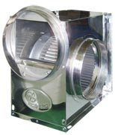 |  |  | 1/220/60 | 428 | 2,520 | 25 | 1,130 | 60 | 20.3
TIS-S250GS |  |  |  | 1/220/50 | 342 | 2,190 | 19 | 985 | 60 | 20.3
TIS-S250GT |  |  |  | 3/220-380/60 | 428 | 2,520 | 25 | 1,150 | 60 | 20.3
TIS-S250GT |  |  |  | 3/220-380/50 | 328 | 2,190 | 19 | 990 | 60 | 20.3
TIS-S280FS |  |  |  | 1/220/60 | 1,280 | 3,600 | 45 | 1,725 | 64 | 22.3
TIS-S280FS |  |  |  | 1/220/50 | 935 | 3,060 | 35 | 1,460 | 64 | 22.3
TIS-S280FT |  |  |  | 3/220-380/60 | 1,280 | 3,600 | 45 | 1,710 | 64 | 22.3
TIS-S280FT |  |  |  | 3/220-380/50 | 890 | 3,060 | 35 | 1,455 | 64 | 22.3
Sò lồng sóc lớn (Large sirocco blowers)
TIS-310GS | 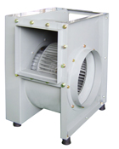 |  |  | 1/220/60 | 1,200 | 5,670 | 21 | 1,130 | 65 | 51
TIS-310GS |  |  |  | 1/220/50 | 890 | 4,875 | 16 | 950 | 65 | 51
TIS-310GT |  |  |  | 3/220-380/60 | 1,200 | 5,670 | 21 | 1,135 | 65 | 51
TIS-310GT |  |  |  | 3/220-380/50 | 830 | 4,875 | 16 | 955 | 65 | 51
TIS-370GS |  |  |  | 1/220/60 | 2,400 | 8,580 | 40 | 1,115 | 67 | 54
TIS-370GS |  |  |  | 1/220/50 | 1,790 | 7,200 | 30 | 965 | 67 | 54
TIS-370GT |  |  |  | 3/220-380/60 | 2,400 | 8,580 | 40 | 1,110 | 67 | 54
TIS-370GT |  |  |  | 3/220-380/50 | 1,690 | 7,200 | 30 | 960 | 67 | 54
TIS-B310FS | 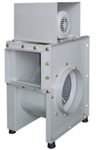 |  |  | 1/220/60 | 1,800 | 7,000 | 35 | 1,690 | 66 | 52
TIS-B310FS |  |  |  | 1/220/50 | 1,335 | 5,985 | 27 | 1,450 | 66 | 52
TIS-B310FT |  |  |  | 3/220-380/440/60 | 1,830 | 7,000 | 35 | 1,710 | 66 | 52
TIS-B310FT |  |  |  | 3/220-380/440/50 | 1,305 | 5,985 | 27 | 1,460 | 66 | 52
TIS-390GT | 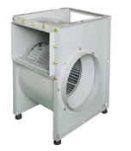 |  |  | 3/220-380/60 | 3,500 | 11,800 | 42 | 1,150 | 69 | 68
TIS-390GT |  |  |  | 3/220-380/50 | 2,270 | 9,900 | 31 | 980 | 69 | 68
TIS-390HT |  |  |  | 3/220-380/60 | 1,700 | 7,800 | 22 | 880 | 65 | 68
TIS-390HT |  |  |  | 3/220-380/50 | 1,428 | 6,550 | 17 | 755 | 65 | 68
Quạt hướng trục thân tròn (Portable fans)
TIP-200S  (Ø170 mm) | 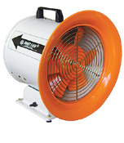 |  |  | 1/220/60 | 190 | 1,140 | 30 | 3,280 | 61 | 6.5
TIP-200S  (Ø170 mm) |  |  |  | 1/220/50 | 140 | 1,250 | 23 | 2,840 | 61 | 6.5
TIP-250S  (Ø220 mm) |  |  |  | 1/220/60 | 310 | 3,060 | 38 | 3,410 | 65 | 7.6
TIP-250S  (Ø220 mm) |  |  |  | 1/220/50 | 230 | 2,660 | 29 | 2,950 | 65 | 7.6
TIP-300S  (Ø270 mm) |  |  |  | 1/220/60 | 440 | 3,780 | 50 | 3,300 | 67 | 11
TIP-300S  (Ø270 mm) |  |  |  | 1/220/50 | 325 | 3,280 | 38 | 2,850 | 67 | 11
TIP-350S  (Ø320 mm) |  |  |  | 1/220/60 | 890 | 6,900 | 80 | 3,420 | 70 | 18
TIP-350S  (Ø320 mm) |  |  |  | 1/220/50 | 658 | 6,010 | 60 | 2,960 | 70 | 18
TIP-250S-1 | 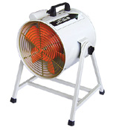 |  |  | 1/220/60 | 310 | 3,060 | 38 | 3,410 | 65 | 7.6
TIP-250S-1 |  |  |  | 1/220/50 | 230 | 2,660 | 29 | 2,950 | 65 | 7.6
TIP-300S-1 |  |  |  | 1/220/60 | 440 | 3,780 | 50 | 3,300 | 67 | 11
TIP-300S-1 |  |  |  | 1/220/50 | 325 | 3,280 | 38 | 2,850 | 67 | 11
TIP-400S | 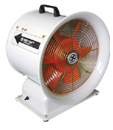 |  |  | 1/220/60 | 400 | 6,060 | 30 | 1,620 | 66 | 22.8
TIP-400S |  |  |  | 1/220/50 | 280 | 5,272 | 23 | 1,415 | 66 | 22.8
TIP-500S |  |  |  | 1/220/60 | 990 | 10,560 | 39 | 1,680 | 69 | 31.2
TIP-500S |  |  |  | 1/220/50 | 690 | 8,970 | 29 | 1,465 | 69 | 31.2
TIP-400S-1  (Ø370 mm) | 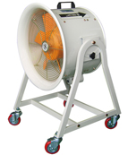 |  |  | 1/220/60 | 400 | 6,060 | 30 | 1,620 | 66 | 24.2
TIP-400S-1  (Ø370 mm) |  |  |  | 1/220/50 | 280 | 5,272 | 23 | 1,415 | 66 | 24.2
TIP-400T-1  (Ø370 mm) |  |  |  | 3/220-380/60 | 400 | 6,060 | 30 | 1,650 | 66 | 24.2
TIP-400T-1  (Ø370 mm) |  |  |  | 3/220-380/50 | 280 | 5,272 | 23 | 1,435 | 66 | 24.2
TIP-500S-1  (Ø470 mm) |  |  |  | 1/220/60 | 990 | 10,560 | 39 | 1,680 | 69 | 34.6
TIP-500S-1  (Ø470 mm) |  |  |  | 1/220/50 | 690 | 8,970 | 29 | 1,465 | 69 | 34.6
TIP-500T-1  (Ø470 mm) |  |  |  | 3/220-380/60 | 990 | 10,560 | 39 | 1,690 | 69 | 34.6
TIP-500T-1  (Ø470 mm) |  |  |  | 3/220-380/50 | 690 | 8,970 | 29 | 1,455 | 69 | 34.6
TIP-600S-1 | 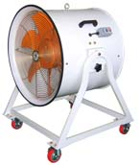 |  |  | 1/220/60 | 1,400 | 25,200 | 60 | 1,620 | 88 | 57
TIP-600S-1 |  |  |  | 1/220/50 | 850 | 21,000 | 43 | 1,415 | 88 | 57
TIP-600T-1 |  |  |  | 3/220-380/60 | 1,260 | 25,200 | 60 | 1,650 | 88 | 57
TIP-600T-1 |  |  |  | 3/220-380/50 | 850 | 21,300 | 43 | 1,415 | 88 | 57
TIP-400D  (Ø370 mm) | 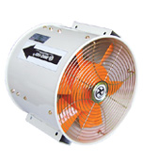 |  |  | 1/220/60 | 400 | 6,060 | 30 | 1,620 | 66 | 14.5
TIP-400D  (Ø370 mm) |  |  |  | 1/220/50 | 280 | 5,272 | 23 | 1,415 | 66 | 14.5
TIP-400DT  (Ø370 mm) |  |  |  | 3/220-380/60 | 400 | 6,060 | 30 | 1,650 | 66 | 15.5
TIP-400DT  (Ø370 mm) |  |  |  | 3/220-380/50 | 280 | 5,272 | 23 | 1,435 | 66 | 15.5
TIP-500D  (Ø470 mm) |  |  |  | 1/220/60 | 990 | 10,560 | 39 | 1,680 | 69 | 23
TIP-500D  (Ø470 mm) |  |  |  | 1/220/50 | 690 | 8,970 | 29 | 1,465 | 69 | 23
TIP-500DT  (Ø470 mm) |  |  |  | 3/220-380/60 | 990 | 10,560 | 39 | 1,690 | 69 | 23
TIP-500DT  (Ø470 mm) |  |  |  | 3/220-380/50 | 690 | 8,970 | 29 | 1,455 | 69 | 23
TIP-600DS | 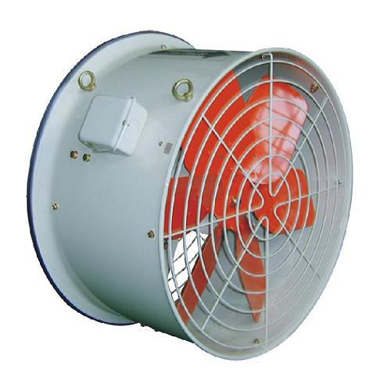 |  |  | 1/220/60 | 439 | 15,600 | 29 | 1,130 | 66 | 33
TIP-600DS |  |  |  | 1/220/50 | 315 | 13,200 | 21 | 985 | 66 | 33
TIP-600DT |  |  |  | 3/220-380/60 | 439 | 15,600 | 29 | 1,120 | 66 | 33
TIP-600DT |  |  |  | 3/220-380/50 | 315 | 13,200 | 21 | 965 | 66 | 33
Quạt thổi áp lực cao (High-pressure blowers)
TBS-230  (Ø20.5 cm) | 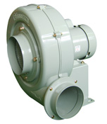 |  |  | 1/220/60 | 330 | 660 | 120 | 3,440 | 83 | 12
TBS-230  (Ø20.5 cm) |  |  |  | 1/220/50 | 220 | 570 | 90 | 2,970 | 83 | 12
TBT-230  Ø20.5 cm) |  |  |  | 3/220-380/60 | 340 | 660 | 120 | 3,300 | 83 | 12
TBT-230  Ø20.5 cm) |  |  |  | 3/220-380/50 | 260 | 570 | 90 | 2,850 | 83 | 12
TBS-270  Ø24.5 cm) |  |  |  | 1/220/60 | 680 | 1,200 | 170 | 3,430 | 80 | 15
TBS-270  Ø24.5 cm) |  |  |  | 1/220/50 | 500 | 1,080 | 130 | 2,960 | 80 | 15
TBT-270  Ø24.5 cm) |  |  |  | 3/220-380/60 | 670 | 1,200 | 170 | 3,430 | 80 | 15
TBT-270  Ø24.5 cm) |  |  |  | 3/220-380/50 | 470 | 1,080 | 130 | 2,960 | 80 | 15
TBS-230S  (Ø20.5 cm) | 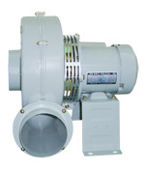 |  |  | 1/220/60 | 330 | 660 | 120 | 3,440 | 83 | 12.5
TBS-230S  (Ø20.5 cm) |  |  |  | 1/220/50 | 220 | 570 | 90 | 2,970 | 83 | 12.5
TBT-230S  Ø20.5 cm) |  |  |  | 3/220-380/60 | 340 | 660 | 120 | 3,300 | 83 | 12.5
TBT-230S  Ø20.5 cm) |  |  |  | 3/220-380/50 | 260 | 570 | 90 | 2,850 | 83 | 12.5
TBS-270S  Ø24.5 cm) |  |  |  | 1/220/60 | 680 | 1,200 | 170 | 3,430 | 80 | 15.5
TBS-270S  Ø24.5 cm) |  |  |  | 1/220/50 | 500 | 1,080 | 130 | 2,960 | 80 | 15.5
TBT-270S  Ø24.5 cm) |  |  |  | 3/220-380/60 | 670 | 1,200 | 170 | 3,430 | 80 | 15.5
TBT-270S  Ø24.5 cm) |  |  |  | 3/220-380/50 | 470 | 1,080 | 130 | 2,960 | 80 | 15.5
TBS-300 | 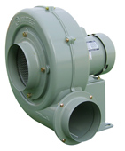 |  |  | 1/220/60 | 840 | 1,380 | 190 | 3,350 | 76 | 18.5
TBS-300 |  |  |  | 1/220/50 | 570 | 1,200 | 145 | 2,890 | 76 | 18.5
TBT-300 |  |  |  | 3/220-380/60 | 850 | 1,380 | 190 | 3,360 | 76 | 18.5
TBT-300 |  |  |  | 3/220-380/50 | 570 | 1,200 | 145 | 2,890 | 76 | 18.5
TBS-300S | 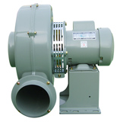 |  |  | 1/220/60 | 840 | 1,380 | 190 | 3,350 | 76 | 19
TBS-300S |  |  |  | 1/220/50 | 570 | 1,200 | 145 | 2,890 | 76 | 19
TBT-300S |  |  |  | 3/220-380/60 | 850 | 1,380 | 190 | 3,360 | 76 | 19
TBT-300S |  |  |  | 3/220-380/50 | 570 | 1,200 | 145 | 2,890 | 76 | 19
TBS-301  (Ø275 mm) | 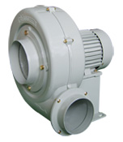 |  |  | 1/220/60 | 1,010 | 1,620 | 206 | 3,430 | 85 | 19
TBS-301  (Ø275 mm) |  |  |  | 1/220/50 | 675 | 1,380 | 155 | 2,960 | 85 | 19
TBT-301  (Ø275 mm) |  |  |  | 3/220-380/60 | 1,030 | 1,620 | 206 | 3,430 | 85 | 19
TBT-301  (Ø275 mm) |  |  |  | 3/220-380/50 | 650 | 1,380 | 155 | 2,960 | 85 | 19
TBS-302  (Ø275 mm) |  |  |  | 1/220/60 | 1,050 | 1,710 | 215 | 3,450 | 86 | 20
TBS-302  (Ø275 mm) |  |  |  | 1/220/50 | 720 | 1,500 | 165 | 2,960 | 86 | 20
TBT-301  (Ø275 mm) |  |  |  | 3/220-380/60 | 1,050 | 1,710 | 215 | 3,450 | 86 | 20
TBT-301  (Ø275 mm) |  |  |  | 3/220-380/50 | 570 | 1,500 | 165 | 2,960 | 86 | 20
TBS-301S  (Ø275 mm) | 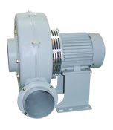  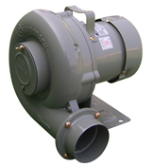 |  |  | 1/220/60 | 1,010 | 1,620 | 206 | 3,430 | 85 | 19
TBS-301S  (Ø275 mm) |  |  |  | 1/220/50 | 675 | 1,380 | 155 | 2,960 | 85 | 19
TBT-301S  (Ø275 mm) |  |  |  | 3/220-380/60 | 1,030 | 1,620 | 206 | 3,430 | 85 | 19
TBT-301S  (Ø275 mm) |  |  |  | 3/220-380/50 | 650 | 1,380 | 155 | 2,960 | 85 | 19
TBS-302S  (Ø275 mm) |  |  |  | 1/220/60 | 1,050 | 1,710 | 215 | 3,450 | 86 | 20.5
TBS-302S  (Ø275 mm) |  |  |  | 1/220/50 | 720 | 1,500 | 165 | 2,960 | 86 | 20.5
TBT-302S  (Ø275 mm) |  |  |  | 3/220-380/60 | 1,050 | 1,710 | 215 | 3,450 | 86 | 20.5
TBT-302S  (Ø275 mm) |  |  |  | 3/220-380/50 | 570 | 1,500 | 165 | 2,960 | 86 | 20.5
TB-2B  (Ø185 mm) |  |  |  | 1/220/60 | 510 | 1,050 | 120 | 3,400 | 68 | 12
TB-2B  (Ø185 mm) |  |  |  | 1/220/50 | 350 | 900 | 90 | 2,920 | 68 | 12
TB-2B  (Ø185 mm) |  |  |  | 3/220-380/60 | 510 | 1,050 | 120 | 3,350 | 68 | 12
TB-2B  (Ø185 mm) |  |  |  | 3/220-380/50 | 360 | 900 | 90 | 2,920 | 68 | 12
TB-4B  (Ø150 mm) |  |  |  | 1/220/60 | 210 | 426 | 75 | 3,400 | 67 | 7.5
TB-4B  (Ø150 mm) |  |  |  | 1/220/50 | 180 | 360 | 50 | 2,900 | 67 | 7.5
TB-4B  (Ø150 mm) |  |  |  | 3/220-380/60 | 230 | 426 | 75 | 3,400 | 67 | 7.5
TB-4B  (Ø150 mm) |  |  |  | 3/220-380/50 | 210 | 360 | 50 | 2,900 | 67 | 7.5
TB-2S  (Ø185 mm) | 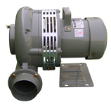 |  |  | 1/220/60 | 510 | 1,050 | 120 | 3,400 | 68 | 12.5
TB-2S  (Ø185 mm) |  |  |  | 1/220/50 | 350 | 900 | 90 | 2,920 | 68 | 12.5
TB-2S  (Ø185 mm) |  |  |  | 3/220-380/60 | 510 | 1,050 | 120 | 3,350 | 68 | 12.5
TB-2S  (Ø185 mm) |  |  |  | 3/220-380/50 | 360 | 900 | 90 | 2,920 | 68 | 12.5
TB-4S  (Ø150 mm) |  |  |  | 1/220/60 | 210 | 426 | 75 | 3,400 | 67 | 8
TB-4S  (Ø150 mm) |  |  |  | 1/220/50 | 180 | 360 | 50 | 2,900 | 67 | 8
TB-4S  (Ø150 mm) |  |  |  | 3/220-380/60 | 230 | 426 | 75 | 3,400 | 67 | 8
TB-4S  (Ø150 mm) |  |  |  | 3/220-380/50 | 210 | 360 | 50 | 2,900 | 67 | 8
Sò thổi nhỏ (Small blowers)
TB-75 | 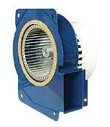 |  | 1/220/60 |  | 29 | 84 | 16 | 2,350 | 35 | 0.9
TB-75 |  |  | 1/220/50 |  | 23 | 78 | 14 | 2,245 | 35 | 0.9
TB-95 | 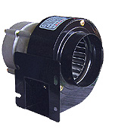 |  | 1/220/60 |  | 40 | 162 | 22 | 3,140 | 39 | 1.3
TB-95 |  |  | 1/220/50 |  | 32 | 128 | 18 | 2,730 | 39 | 1.3
TB-105 | 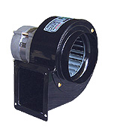 |  | 1/220/60 |  | 60 | 300 | 37 | 3,070 | 42 | 2.1
TB-105 |  |  | 1/220/50 |  | 48 | 240 | 32 | 2,730 | 42 | 2.1
TB-105F | 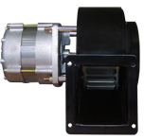 |  | 1/220/60 |  | 60 | 300 | 37 | 3,070 | 42 | 2.1
TB-105F |  |  | 1/220/50 |  | 48 | 270 | 32 | 2,730 | 42 | 2.1
TB-118 | 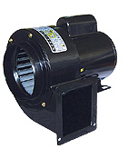 |  | 1/220/60 |  | 100 | 360 | 43 | 3,380 | 58 | 3.3
TB-118 |  |  | 1/220/50 |  | 91 | 324 | 30 | 2,910 | 58 | 3.3
TB-95-1 | 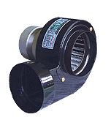 |  | 1/220/60 |  | 40 | 162 | 22 | 3,450 | 39 | 1.3
TB-95-1 |  |  | 1/220/50 |  | 32 | 128 | 18 | 2,960 | 39 | 1.3
TB-115 |  |  | 1/220/60 |  | 60 | 300 | 37 | 3,450 | 42 | 2.1
TB-115 |  |  | 1/220/50 |  | 48 | 240 | 32 | 2,960 | 42 | 2.1
TB-118-1 | 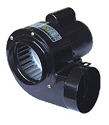 |  | 1/220/60 |  | 100 | 360 | 43 | 3,380 | 58 | 3.3
TB-118-1 |  |  | 1/220/50 |  | 91 | 324 | 30 | 2,910 | 58 | 3.3
TB-150  Ø118x60 |  |  | 1/220/60 |  | 209 | 480 | 49 | 3,470 | 62 | 6.4
TB-150  Ø118x60 |  |  | 1/220/50 |  | 167 | 406 | 37 | 2,895 | 62 | 6.4
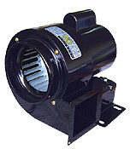  TB-150(3pha)  Ø118x60 |  |  | 3/220-380/60 |  | 209 | 480 | 49 | 3,410 | 62 | 6.4
 |  |  | 1/220/50 |  | 152 | 406 | 37 | 2,900 | 62 | 6.4
TB-200  Ø148x80 |  |  | 3/220-380/60 |  | 485 | 960 | 79 | 3,275 | 64 | 9
TB-200  Ø148x80 |  |  | 1/220/50 |  | 367 | 844 | 62 | 2,865 | 64 | 9
TB-200(3pha)  Ø148x80 |  |  | 3/220-380/60 |  | 485 | 960 | 79 | 3,320 | 64 | 9
TB-200(3pha)  Ø148x80 |  |  | 1/220/50 |  | 386 | 844 | 62 | 2,895 | 64 | 9
TB-105S | 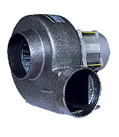 |  | 1/220/60 |  | 60 | 330 | 40 | 3,170 | 58 | 2.4
TB-105S |  |  | 1/220/50 |  | 52 | 287 | 30 | 2,765 | 58 | 2.4
TB-118S |  |  | 1/220/60 |  | 160 | 540 | 46 | 3,150 | 60 | 6.6
TB-118S |  |  | 1/220/50 |  | 139 | 470 | 30 | 2,760 | 60 | 6.6
TB-105S-1 | 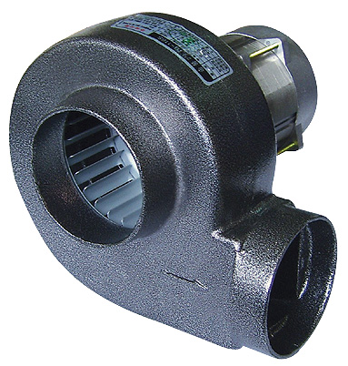 |  | 1/220/60 |  | 60 | 330 | 40 | 3,170 | 58 | 2.3
TB-105S-1 |  |  | 1/220/50 |  | 52 | 287 | 30 | 2,765 | 58 | 2.3
TB-118S-1 |  |  | 1/220/60 |  | 160 | 540 | 46 | 3,150 | 60 | 6.5
TB-118S-1 |  |  | 1/220/50 |  | 139 | 470 | 30 | 2,760 | 60 | 6.5
TB-12B | 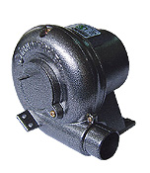 |  | 1/220/60 |  | 60 | 72 | 30 | 3,440 | 45 | 2.3
TB-12B |  |  | 1/220/50 |  | 60 | 72 | 30 | 2,890 | 45 | 2.3
TB-8B |  |  | 1/220/60 |  | 131 | 198 | 66 | 3,440 | 60 | 3.5
TB-8B |  |  | 1/220/50 |  | 131 | 198 | 66 | 2,830 | 60 | 3.5
TB-6B | 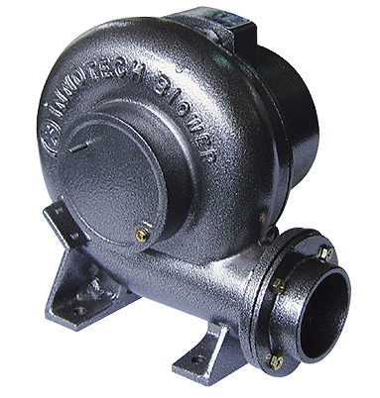 |  | 1/220/60 |  | 160 | 250 | 72 | 3,365 | 62 | 4.7
TB-6B |  |  | 1/220/50 |  | 125 | 232 | 66 | 2,890 | 62 | 4.7
TB-140DS | 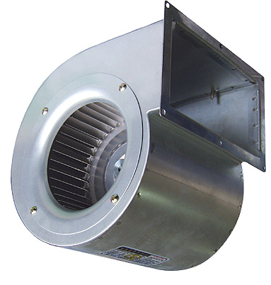 |  | 1/220/60 |  | 125 | 720 | 17 | 1,540 | 62 | 3
TB-140DS |  |  | 1/220/50 |  | 83 | 675 | 14 | 1,230 | 62 | 3
TJF-15B | 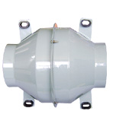 |  | 1/220/60 |  | 117 | 600 | 42 | 2,950 | 67 | 3.7
TJF-15B |  |  | 1/220/50 |  | 95 | 516 | 32 | 2,640 | 67 | 3.7
TJF-20B | 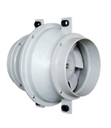 |  | 1/220/60 |  | 57 | 840 | 20 | 1,615 | 54 | 4.5
TJF-20B |  |  | 1/220/50 |  | 55 | 720 | 15 | 1,420 | 54 | 4.5
TJF-25B |  |  | 1/220/60 |  | 91 | 1,440 | 30 | 1,625 | 58 | 6.8
TJF-25B |  |  | 1/220/50 |  | 73 | 1,220 | 23 | 1,420 | 58 | 6.8
TJF-30B |  |  | 1/220/60 |  | 240 | 2,520 | 40 | 1,660 | 62 | 10.8
TJF-30B |  |  | 1/220/50 |  | 170 | 2,140 | 30 | 1,425 | 62 | 10.8
TJF-200B | 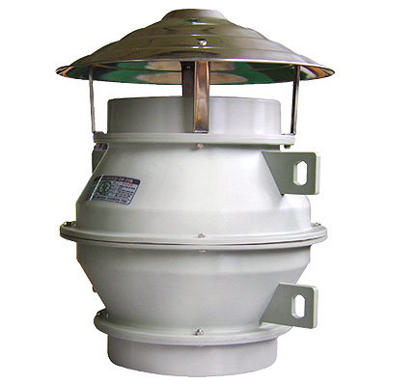 |  |  | 1/220/60 | 57 | 840 | 20 | 1,615 | 54 | 5.5
TJF-200B |  |  |  | 1/220/50 | 55 | 720 | 15 | 1,420 | 54 | 5.5
TJF-250B |  |  |  | 1/220/60 | 91 | 1,440 | 30 | 1,625 | 58 | 8.3
TJF-250B |  |  |  | 1/220/50 | 73 | 1,220 | 23 | 1,420 | 58 | 8.3
TJF-300B |  |  |  | 1/220/60 | 240 | 2,520 | 40 | 1,660 | 62 | 12
TJF-300B |  |  |  | 1/220/50 | 170 | 2,140 | 30 | 1,425 | 62 | 12

SẢN PHẨM | TÊN SẢN PHẨM | SỐ TIỀN | SẢN PHẢM |  | TÊN SẢN PHẨM |  | SỐ TIỀN
QUẠT CAO ÁP  ( TIÊU CHUẨN)  고압송풍기  (일반용) | TBS-230 | 6,369,723 | ĐA TẦNG TURBO  (TIÊU CHUẨN) |  | ITB-401S |  | 15,956,740
QUẠT CAO ÁP  ( TIÊU CHUẨN)  고압송풍기  (일반용) | TBT-230 | 6,369,723 |  |  | ITB-401T |  | 14,724,309
QUẠT CAO ÁP  ( TIÊU CHUẨN)  고압송풍기  (일반용) | TBS-270 | 8,432,424 |  |  | ITB-402S |  | 21,470,248
QUẠT CAO ÁP  ( TIÊU CHUẨN)  고압송풍기  (일반용) | TBT-270 | 8,432,424 |  |  | ITB-402T |  | 20,237,817
QUẠT CAO ÁP  ( TIÊU CHUẨN)  고압송풍기  (일반용) | TBS-300 | 10,832,422 |  |  | ITB-403T |  | 26,918,892
QUẠT CAO ÁP  ( TIÊU CHUẨN)  고압송풍기  (일반용) | TBT-300 | 10,832,422 |  |  | ITB-404T |  | 31,913,481
QUẠT CAO ÁP  ( TIÊU CHUẨN)  고압송풍기  (일반용) | TBS-301 | 14,399,986 |  |  | ITB-405T |  | 38,724,285
QUẠT CAO ÁP  ( TIÊU CHUẨN)  고압송풍기  (일반용) | TBT-301 | 13,945,932 |  |  | ITB-406T |  | 42,486,444
QUẠT CAO ÁP  ( TIÊU CHUẨN)  고압송풍기  (일반용) | TBS-302 | 18,940,522 | BLOWER  NHIỆT ĐỘ CAO |  | ITB-S401S고온용CF |  | 17,772,955
QUẠT CAO ÁP  ( TIÊU CHUẨN)  고압송풍기  (일반용) | TBT-302 | 18,616,198 |  |  | ITB-S401T고온용CF |  | 16,540,524
QUẠT CAO ÁP  ( NHIỆT ĐỘ CAO)  고압송풍기  (고온용) | TBS-230S | 8,302,694 |  |  | ITB-S402S고온용CF |  | 23,351,328
QUẠT CAO ÁP  ( NHIỆT ĐỘ CAO)  고압송풍기  (고온용) | TBT-230S | 8,302,694 |  |  | ITB-S402T고온용CF |  | 21,924,302
QUẠT CAO ÁP  ( NHIỆT ĐỘ CAO)  고압송풍기  (고온용) | TBS-270S | 10,832,422 |  |  | ITB-S403T고온용AF
QUẠT CAO ÁP  ( NHIỆT ĐỘ CAO)  고압송풍기  (고온용) | TBT-270S | 10,832,422 |  |  | ITB-S404T고온용AF
QUẠT CAO ÁP  ( NHIỆT ĐỘ CAO)  고압송풍기  (고온용) | TBS-300S | 12,064,853 |  |  | ITB-S405T고온용AF
QUẠT CAO ÁP  ( NHIỆT ĐỘ CAO)  고압송풍기  (고온용) | TBT-300S | 12,064,853 |  |  | ITB-S406T고온용AF
QUẠT CAO ÁP  ( NHIỆT ĐỘ CAO)  고압송풍기  (고온용) | TBS-301S | 17,448,631 | BLOWRE ĐA TẦNG |  | ITB-411(1∮) |  | 21,535,113
QUẠT CAO ÁP  ( NHIỆT ĐỘ CAO)  고압송풍기  (고온용) | TBT-301S | 17,189,172 |  |  | ITB-411 (3∮) |  | 20,172,952
QUẠT CAO ÁP  ( NHIỆT ĐỘ CAO)  고압송풍기  (고온용) | TBS-302S | 21,210,790 |  |  | ITB-412 (3∮) |  | 26,399,973
QUẠT CAO ÁP  ( NHIỆT ĐỘ CAO)  고압송풍기  (고온용) | TBT-302S | 20,756,736 |  |  | ITB-413 (3∮) |  | 31,459,428
QUẠT HÚT BỤI | IDT-100S |  |  |  | ITB-414 (3∮) |  | 38,918,880
QUẠT HÚT BỤI | IDT-100T |  | NHIỆT ĐỘ CAO |  | ITB-11S(1∮)고온용CF |  | 23,545,922
QUẠT HÚT BỤI | IDT-200S |  |  |  | ITB-11S(3∮)고온용CF |  | 22,378,356
QUẠT HÚT BỤI | IDT-200T |  |  |  | ITB-12S(3∮)고온용AF
QUẠT HÚT BỤI | IDT-300S |  |  |  | ITB-13S(3∮)고온용AF
QUẠT HÚT BỤI | IDT-300T |  |  |  | ITB-14S(3∮)고온용AF
QUẠT HÚT BỤI | IDT-500T
QUẠT HÚT BỤI | IDT-750T
QUẠT HÚT BỤI | IDT-1000T
SẢN PHẨM | TÊN SẢN PHẨM | SỐ TIỀN |  | SẢN PHẨM |  | TÊN SẢN PHẨM |  | SỐ TIỀN
QUẠT SÒ CAO ÁP LOẠI NHỎ | TB-70 | 836,756 |  | QUẠT TORBO |  | TBS-3235S(1HP) |  | 12,778,366
QUẠT SÒ CAO ÁP LOẠI NHỎ | TB-70-1 | 836,756 |  |  |  | TBS-3245S(2HP) |  | 14,464,850
QUẠT SÒ CAO ÁP LOẠI NHỎ | TB-75 | 836,756 |  |  |  | TBS-3735S(3HP) |  | 17,189,172
QUẠT SÒ CAO ÁP LOẠI NHỎ | TB-95 | 1,141,620 |  |  |  | TBS-3235T(1HP) |  | 11,740,529
QUẠT SÒ CAO ÁP LOẠI NHỎ | TB-95N | 1,264,864 |  |  |  | TBS-3245T(2HP) |  | 13,297,284
QUẠT SÒ CAO ÁP LOẠI NHỎ | TB-105 | 1,368,647 |  |  |  | TBS-3735T(3HP) |  | 15,632,417
QUẠT SÒ CAO ÁP LOẠI NHỎ | TB-118 | 2,257,295 |  |  |  | TBS-3765T(5HP) |  | 17,967,550
QUẠT SÒ CAO ÁP LOẠI NHỎ | TB-150(1∮) | 3,042,159 |  |  |  | TBS-S3235S(1HP) |  | 17,708,090
QUẠT SÒ CAO ÁP LOẠI NHỎ | TB-150(3∮) | 3,042,159 |  |  |  | TBS-S3245S(2HP) |  | 19,329,710
QUẠT SÒ CAO ÁP LOẠI NHỎ | TB-200(1∮) | 3,729,726 |  |  |  | TBS-S3735S(3HP) |  | 22,054,032
QUẠT SÒ CAO ÁP LOẠI NHỎ | TB-200(3∮) | 3,729,726 |  |  |  | TBS-S3235T(1HP) |  | 16,605,389
QUẠT SÒ CAO ÁP LOẠI NHỎ | TB-95-1 | 1,180,539 |  |  |  | TBS-S3245T(2HP) |  | 18,162,144
QUẠT SÒ CAO ÁP LOẠI NHỎ | TB-115 | 1,439,999 |  |  |  | TBS-S3735T(3HP) |  | 20,497,277
QUẠT SÒ CAO ÁP LOẠI NHỎ | TB-118-1 | 2,361,079 |  |  |  | TBS-S3765T(5HP) |  | 22,897,274
QUẠT SÒ CAO ÁP LOẠI NHỎ | TB-95F | 1,368,647 |  | QUẠT TORBO  THÉP KHÔNG RỈ |  | TBP-3235S(1HP) SUS |  | 28,799,971
QUẠT SÒ CAO ÁP LOẠI NHỎ | TB-105F | 1,751,350 |  |  |  | TBP-3245S(2HP) SUS |  | 32,237,806
QUẠT SÒ CAO ÁP LOẠI NHỎ | TB-118F | 2,769,727 |  |  |  | TBP-3735S(3HP) SUS |  | 37,232,395
QUẠT SÒ CAO ÁP LOẠI NHỎ | TB-150F(1∮) | 3,548,105 |  |  |  | TBP-3235T(1HP) SUS |  | 28,475,647
QUẠT SÒ CAO ÁP LOẠI NHỎ | TB-150F(3∮) | 3,548,105 |  |  |  | TBP-3245T(2HP) SUS |  | 31,264,834
QUẠT SÒ CAO ÁP LOẠI NHỎ | TB-200F(1∮) | 4,281,077 |  |  |  | TBP-3735T(3HP) SUS |  | 36,194,558
QUẠT SÒ CAO ÁP LOẠI NHỎ | TB-200F(3∮) | 4,281,077 |  |  |  | TBP-3765T(5HP) SUS |  | 41,189,148
QUẠT SÒ CAO ÁP LOẠI NHỎ | TB-95-1F | 1,414,053 |  |  |  | TBP-S3235S(1HP) SUS |  | 33,729,696
QUẠT SÒ CAO ÁP LOẠI NHỎ | TB-115F | 1,790,268 |  |  |  | TBP-S3245S(2HP) SUS |  | 37,232,395
QUẠT SÒ CAO ÁP LOẠI NHỎ | TB-118-1F | 2,970,808 |  |  |  | TBP-S3735S(3HP) SUS |  | 42,162,120
QUẠT SÒ CAO ÁP LOẠI NHỎ | TB-150(100Φ) | 155,676 |  |  |  | TBP-S3235T(1HP) SUS |  | 33,405,372
QUẠT SÒ CAO ÁP LOẠI NHỎ | TB-200(125Φ) | 175,135 |  |  |  | TBP-S3245T(2HP) SUS |  | 36,194,558
QUẠT SÒ THÉP KHÔNG RỈ | TB-105(SS) | 3,068,105 |  |  |  | TBP-S3735T(3HP) SUS |  | 41,189,148
QUẠT SÒ THÉP KHÔNG RỈ | TB-118(SS) | 4,436,752 |  |  |  | TBP-S3765T(5HP) SUS |  | 46,183,738
QUẠT SÒ THÉP KHÔNG RỈ | TB-150(1∮)(SS) | 5,286,481 |  | QUẠT SÒ CO ÁP NHỎ |  | TB-12B |  | 1,744,863
QUẠT SÒ THÉP KHÔNG RỈ | TB-150(3∮)(SS) | 5,286,481 |  |  |  | TB-8B |  | 2,328,646
QUẠT SÒ THÉP KHÔNG RỈ | TB-200(1∮)(SS) | 6,460,534 |  |  |  | TB-6B |  | 2,970,808
QUẠT SÒ THÉP KHÔNG RỈ | TB-200(3∮)(SS) | 6,460,534 |  |  |  | TB-4B(1∮) |  | 4,079,996
QUẠT SÒ THÉP KHÔNG RỈ | TB-115(SS) | 3,158,916 |  |  |  | TB-4B(3∮) |  | 4,079,996
QUẠT SÒ THÉP KHÔNG RỈ | TB-118-1(SS) | 4,527,563 |  |  |  | TB-2B(1∮) |  | 5,156,752
QUẠT SÒ THÉP KHÔNG RỈ | TB-105F(SS) | 3,347,024 |  |  |  | TB-2B(3∮) |  | 5,156,752
QUẠT SÒ THÉP KHÔNG RỈ | TB-118F(SS) | 4,670,266 |  |  |  | TB-4S(1∮) |  | 5,104,860
QUẠT SÒ THÉP KHÔNG RỈ | TB-150F(1∮)(SS) | 5,662,697 |  |  |  | TB-4S(3∮) |  | 5,104,860
QUẠT SÒ THÉP KHÔNG RỈ | TB-150F(3∮)(SS) | 5,662,697 |  |  |  | TB-2S(1∮) |  | 6,071,345
QUẠT SÒ THÉP KHÔNG RỈ | TB-200F(1∮)(SS) | 6,810,804 |  |  |  | TB-2S(3∮) |  | 6,071,345
QUẠT SÒ THÉP KHÔNG RỈ | TB-200F(3∮)(SS) | 6,810,804 |  | QUẠT SÒ VỎ NHÔM |  | TB-105S/TBW-51 (신형) |  | 1,848,647
QUẠT SÒ THÉP KHÔNG RỈ | TB-115F(SS) | 3,444,321 |  |  |  | TB-105S-1(신형) |  | 1,731,890
QUẠT SÒ THÉP KHÔNG RỈ | TB-118-1F(SS) | 4,858,374 |  |  |  | TBW-101 (CW) |  | 3,256,213
QUẠT SÒ THÉP KHÔNG RỈ | TB-150(SS)(100Φ) | 661,621 |  |  |  | TBW-103 (CW) |  | 3,256,213
QUẠT SÒ THÉP KHÔNG RỈ | TB-200(SS)(125Φ) | 752,432 |  |  |  | TBW-101-1 (CW) |  | 3,107,024
 | TB-F105S | 2,082,160 |  |  |  | TBW-103-1 (CW) |  | 3,107,024
 | TBW-101F (CW) | 3,548,105 |  |  |  | TIV-200D |  | 9,405,396
 | TBW-103F (CW) | 3,548,105 |  |  |  | TIV-250D |  | 9,989,179
 | TB105SM(신형) | 1,472,431 |  | QUẠT SÒ NHỎ THỔI LÒ |  | TB-105S |  | 1,699,458
 | TBW-101M-103M*45*12Ø | 2,062,701 |  |  |  | TB-105S-1 |  | 1,699,458
 | TBW-101FM-103FM*75*12Ø | 2,237,836 |  |  |  | TB-118S |  | 2,432,430
 | TBW-101FM-103FM*114*12Ø | 2,828,105 |  |  |  | TB-118S-1 |  | 2,432,430
SẢN PHẨM | TÊN SẢN PHẨM | SỐ TIỀN |  | SẢN PHẨM |  | TÊN SẢN PHẨM |  | SỐ TIỀN
QUẠT LY TÂM LOẠI THƯỜNG | TIS-140FS | 2,828,105 |  | QUẠT HƯỚNG TRỤC TRÒN LOẠI NHỎ |  | TIP-200S |  | 4,812,968
QUẠT LY TÂM LOẠI THƯỜNG | TIS-160FS | 3,398,916 |  |  |  | TIP-250S |  | 5,422,697
QUẠT LY TÂM LOẠI THƯỜNG | TIS-190FS | 4,339,455 |  |  |  | TIP-300S |  | 6,369,723
QUẠT LY TÂM LOẠI THƯỜNG | TIS-190FT | 4,339,455 |  |  |  | TIP-350S |  | 8,886,478
QUẠT LY TÂM LOẠI THƯỜNG | TIS-250GS | 7,329,722 |  |  |  | TIP-400S |  | 10,702,692
QUẠT LY TÂM LOẠI THƯỜNG | TIS-250GT | 7,329,722 |  |  |  | TIP-400T |  | 10,702,692
QUẠT LY TÂM LOẠI THƯỜNG | TIS-280FS | 8,691,883 |  |  |  | TIP-500S |  | 13,232,419
QUẠT LY TÂM LOẠI THƯỜNG | TIS-280FT | 8,497,289 |  |  |  | TIP-500T |  | 13,232,419
QUẠT LY TÂM LOẠI THƯỜNG | TIS-280GS | 8,691,883 |  | QUẠT HƯỚNG TRỤC TRÒN LOẠI LỚN |  | TIP-300S-1 |  | 7,394,587
QUẠT LY TÂM LOẠI THƯỜNG | TIS-280GT | 8,497,289 |  |  |  | TIP-400S-1 |  | 13,232,419
QUẠT LY TÂM LOẠI THƯỜNG | TIS-290FS | 10,637,827 |  |  |  | TIP-400T-1 |  | 13,232,419
QUẠT LY TÂM LOẠI THƯỜNG | TIS-290FT | 10,378,368 |  |  |  | TIP-500S-1 |  | 16,994,578
QUẠT LY TÂM LOẠI THƯỜNG | TIS-290GS | 8,951,342 |  |  |  | TIP-500T-1 |  | 16,994,578
2.5HP | TIS-B310FS(belt) | 25,945,920 |  |  |  | TIP-600S-1 |  | 23,610,787
2.5HP | TIS-B310FT(belt) | 25,945,920 |  |  |  | TIP-600T-1 |  | 23,481,058
QUẠT LY TÂM LOẠI LỚN | TIS-310GS | 20,627,006 |  | QUẠT HƯỚNG TRỤC LOẠI CÔNG NGHIỆP |  | TIP-400D(4P) |  | 10,572,962
QUẠT LY TÂM LOẠI LỚN | TIS-310GT | 20,043,223 |  |  |  | TIP-400D(4P) |  | 10,572,962
QUẠT LY TÂM LOẠI LỚN | TIS-370GS | 23,675,652 |  |  |  | TIP-500DS |  | 12,259,447
QUẠT LY TÂM LOẠI LỚN | TIS-370GT | 21,470,249 |  |  |  | TIP-500DT |  | 12,259,447
QUẠT LY TÂM LOẠI LỚN | TIS-390GT | 24,518,894 |  |  |  | TIP-600DS(6P) |  | 15,048,634
QUẠT LY TÂM LOẠI LỚN | TIS-390HT | 24,518,894 |  |  |  | TIP-600DT(6P) |  | 15,048,634
QUẠT LY TÂM THÉP KHÔNG RỈ | TIS-S250GS(SUS) | 27,048,622 |  |  |  | TIP-800DS(6P) |  | 18,875,657
QUẠT LY TÂM THÉP KHÔNG RỈ | TIS-S250GT(SUS) | 27,048,622 |  |  |  | TIP-800DT(6P) |  | 18,875,657
QUẠT LY TÂM THÉP KHÔNG RỈ | TIS-S280FS(SUS) | 29,059,430 |  | QUẠT HƯỚNG TRỤC VUÔNG THÔNG GIÓ |  | TIH-200S |  | 1,414,053
QUẠT LY TÂM THÉP KHÔNG RỈ | TIS-S280FT(SUS) | 29,059,430 |  |  |  | TIH-250S |  | 1,530,809
 | TB-140DS | 1,744,863 |  |  |  | TIH-300S |  | 1,718,917
LY TÂM HỘP LỚN - NHỎ | ITC-230GS | 10,637,827 |  |  |  | TIH-350S |  | 2,192,430
LY TÂM HỘP LỚN - NHỎ | ITC-230GT | 10,508,098 |  |  |  | TIH-400S |  | 2,925,402
LY TÂM HỘP LỚN - NHỎ | ITC-250GS | 11,351,340 |  |  |  | TIH-400T |  | 3,016,213
LY TÂM HỘP LỚN - NHỎ | ITC-250GT | 11,286,475 |  |  |  | TIH-450S |  | 6,810,804
LY TÂM HỘP LỚN - NHỎ | ITC-300GS | 14,594,580 |  |  |  | TIH-450T |  | 6,810,804
LY TÂM HỘP LỚN - NHỎ | ITC-300GT | 14,464,850 |  |  |  | TIH-500S |  | 8,432,424
LY TÂM HỘP LỚN - NHỎ | ITC-350FS | 0 |  |  |  | TIH-500GS |  | 8,432,424
LY TÂM HỘP LOẠI LỚN | ITC-350FT | 0 |  |  |  | TIH-500T |  | 8,302,694
LY TÂM HỘP LOẠI LỚN | ITC-380HS | 28,475,647 |  |  |  | IH-15 (600/1) |  | 10,702,692
LY TÂM HỘP LOẠI LỚN | ITC-380HT | 23,091,869 |  |  |  | 8"-300*300 |  | 583,783
LY TÂM HỘP LOẠI LỚN | ITC-400GT | 29,708,078 |  |  |  | 10"-350*350 |  | 668,107
QUẠT  HƯỚNG TRỤC BẦU | TJF-15B | 2,828,105 |  |  |  | 12"-400*400 |  | 752,432
QUẠT  HƯỚNG TRỤC BẦU | TJF-20B | 3,301,618 |  |  |  | 14"-440*440 |  | 875,675
QUẠT  HƯỚNG TRỤC BẦU | TJF-25B | 4,482,158 |  |  |  | 16"-490*490 |  | 1,044,323
QUẠT  HƯỚNG TRỤC BẦU | TJF-30B | 7,329,722 |  |  |  | 20"-620*620 |  | 1,919,998
ĐƯỜNG ỐNG | TJF-200B | 4,248,644 |  | PLASTIC  QUẠT NHỰA |  | TWP-201GD |  | 966,486
ĐƯỜNG ỐNG | TJF-250B | 6,012,967 |  |  |  | TWP-201G |  | 966,486
ĐƯỜNG ỐNG | TJF-300B | 9,924,314 |  |  |  | TWP-251G |  | 1,037,837
QUẠT NHÀ VS | TWP-10C | 369,729 |  |  |  | TWP-301G |  | 1,465,944
QUẠT NHÀ VS | TWP-15C | 415,135 |  |  |  | INV-200G |  | 966,486
 | ELBOW-10C | 110,270 |  |  |  | INV-250G |  | 1,037,837
 | TWP-150CG | 1,199,999 |  |  |  | TWP-20C |  | 629,189
 | TWP-15P | 369,729 |  |  |  | TWP-25C |  | 726,486
 | TWP-20P | 635,675 |  |  |  | INV-20CD |  | 726,486

